

Team EDUCORE_ : David Wan, Matthew Lau, ShiFeng Jin, Ryan Young, Junzhi ‘Jackson’ Chen

TABLE OF CONTENTS

Meet the Team …………………………………………………………........... 3

David Wan ………………………………………………………………. 4

Matthew Lau ……………………………………………………………. 5

ShiFeng Jin ……………………………………………………………. 6

Ryan Young ……………………………………………………………. 7

Junzhi ‘Jackson’ Chen ………………………………………………… 8

Our goals and specialties ……………………………………………………. 9

David Wan

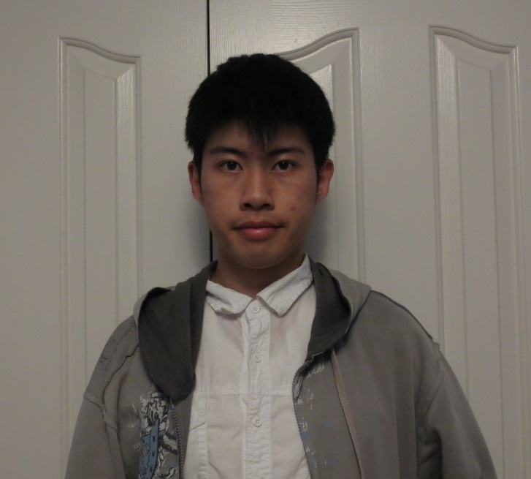

David Wan is a third year Computer Science specialist student at the University of Toronto. His goal is to become deeply entrenched in the world of video game programming and design. He specializes in C++ development whilst having Java and MySQL as an off-hand skill for home IT jobs.

Developing memorable and enjoyable video games for millions to enjoy and making his mark on pop culture is what David is all about. He spends numerous hours of his days with Unreal Engine 4, a powerful game engine that is utilized by indie game developers and triple-A game studios alike. In fact, Unreal Engine is the backbone of his own game dubbed ‘Project Artemis’.

And when he’s not busy hammering away in Unreal Engine, he’s constantly challenging himself and pushing the boundaries of his own abilities. Whether it be hackathons or self-given programming challenges, David is always looking for ways to optimize his performance in game programming and design.

Matthew Lau

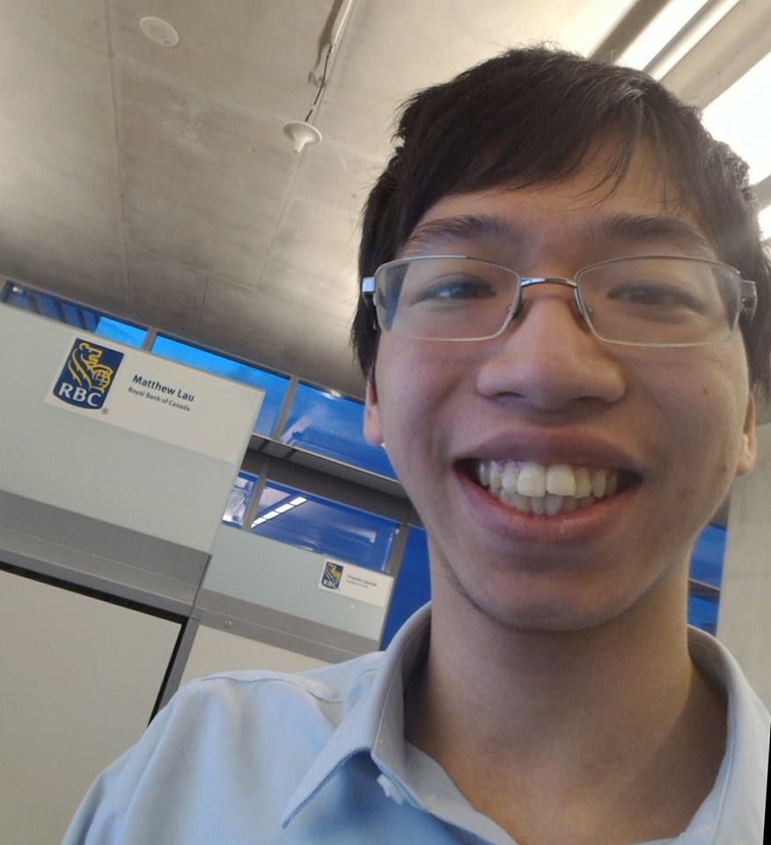

Matthew Lau is a fourth year Computer Science Co-op undergraduate at the University of Toronto Scarborough. He is specializing in Software Engineering. He graduated with honors from Richmond Green Secondary School in 2014.

Matthew has significant experience developing in C# and Java. He has experienced web development using ASP.Net and Struts 2 in a professional environment and is knowledgeable in SQL. He is fantastic at testing as well.

Matthew has great communication skills from discussing projects during meetings and show excellent time management skill from working on tasks with sensitive deadlines. He is creative in his ideas for projects and is great at solving problems when they arise.

Matthew has completed several work-terms at RBC Capital Markets as a Technical Systems Analyst. He has done development for several departments including: Operations IT, Shared Services IT, and Central Funding.

Matthew follows new technology and peripherals through technology focused video publishers. He also has an interest in the early to mid-20th century.

Shifeng Jin

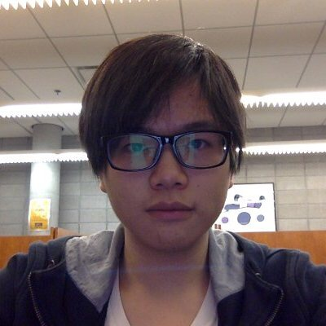

Shifeng Jin is currently in his third year of Computer Science Co-op Specialist Program at University of Toronto Scarborough. As he specializes in Software Engineering, he has been through several dedicated courses where he developed adequate understandings on how to program with Java, python, C, SQL, algorithm and data structures. He also has a year of work experience within a IT department of Ministry of Health, where he built his skill set on web technologies including Nginx, Node.js, Angular.js, React.js and API management, and experienced some best practices on how to operate with Dockers and Cloud Foundry Platform. And additionally, during his work period, he followed closely with a web application project team from the development phase into the production phase, where he was being fully attentive in detail, cooperative in tasking and productive in troubleshooting deployment related issues.